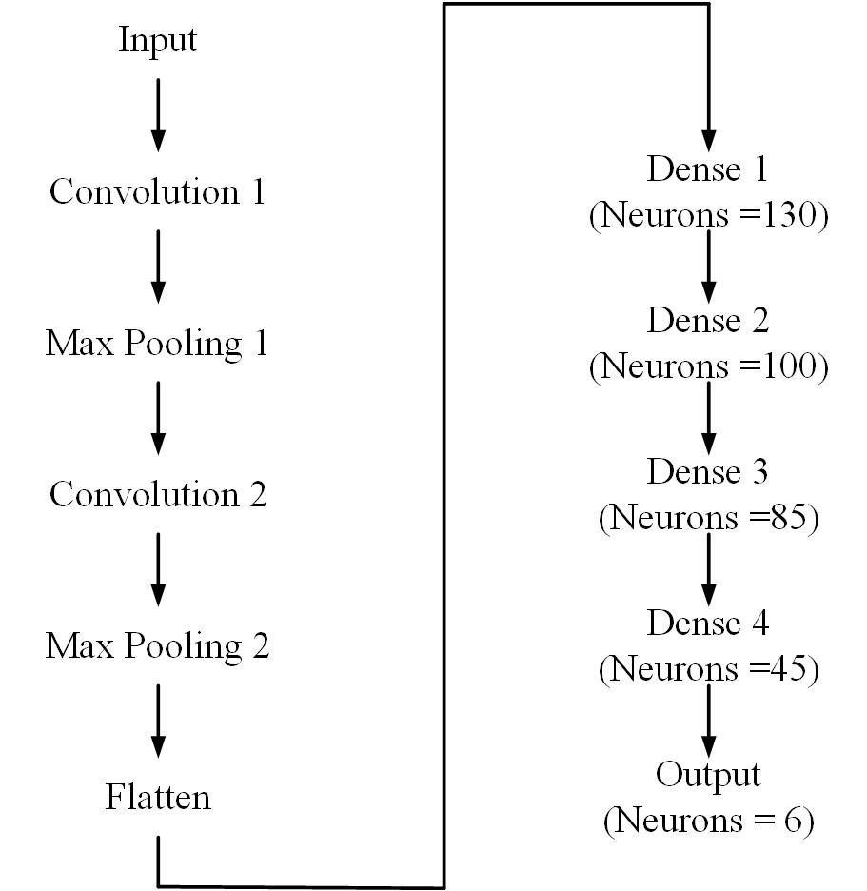

*Figure 1: 1D CNN Layers*

|  |  |  |  |  |  |
| --- | --- | --- | --- | --- | --- |
|  |  |  | 1DCNN |  |  |
| **Actual Levels** | **Predicted Levels** | | | | |
| **2066** | 0 | 87 | 0 | 211 |
| **0** | **2055** | 209 | 58 | 0 |
| 195 | 512 | **1246** | 21 | 321 |
| 0 | 189 | 102 | **1710** | 26 |
| 73 | 0 | 25 | 13 | **2220** |
|  |

|  |  |  |  |  |  |
| --- | --- | --- | --- | --- | --- |
|  |  |  | ANN |  |  |
| **Actual Levels** | **Predicted Levels** | | | | |
| **2369** | 0 | 32 | 0 | 52 |
| **0** | **2365** | 26 | 43 | 7 |
| **0** | 25 | **2246** | 0 | 25 |
| **9** | 2 | 9 | **2286** | 0 |
| **0** | 5 | 0 | 7 | **2285** |

|  |  |  |  |  |  |  |  |  |
| --- | --- | --- | --- | --- | --- | --- | --- | --- |
|  | CNN | | ANN | |  |  |  |  |
| S.no. | Filter size | Kernel size | Dense layer | Neurons | Epochs | Learning Rate | Training Accuracy | Testing Accuracy |
| 1 | 32 | 10 | 1 | 8 | 50 | 10-4 | 66.09 | 66.46 |
| 2 | 32 | 10 | 2 | 16,8 | 50 | 10-4 | 44.1 | 45.22 |
| 3 | 64 | 10 | 1 | 32 | 50 | 10-3 | 66.29 | 66.64 |
| 4 | 64 | 10 | 2 | 32,32 | 50 | 10-3 | 73 | 73.46 |
| 5 | 64 | 10 | 3 | 32,32,32 | 50 | 10-3 | 73.8 | 73.62 |
| 6 | 64 | 10 | 2 | 32,32 | 50 | 10-4 | 72.91 | 73.36 |
| 7 | 100,50 | 5 | 2 | 32,32 | 50 | 10-4 | 71.81 | 72.21 |
| 8 | 100 | 3 | 3 | 50,30,10 | 40 | 10-4 | 74.51 | 75.04 |
| 9 | 250 | 3 | 4 | 130,100,85,45 | 120 | 10-5 | 76.213 | 76.73 |
| 10 | 250,250 | 3 | 4 | 130,100,85,46 | 120 | 10-5 | 80.3 | 80.31 |
| 11 | 260,260 | 3 | 4 | 140,90,55,35 | 151/200 | 10-5 | 81.9 | X |

By adding the three filters in CNN, then it gives the error of negative dimension size caused by subtracting 3 from 1 for conv 1D with input shapes.